--.:..·

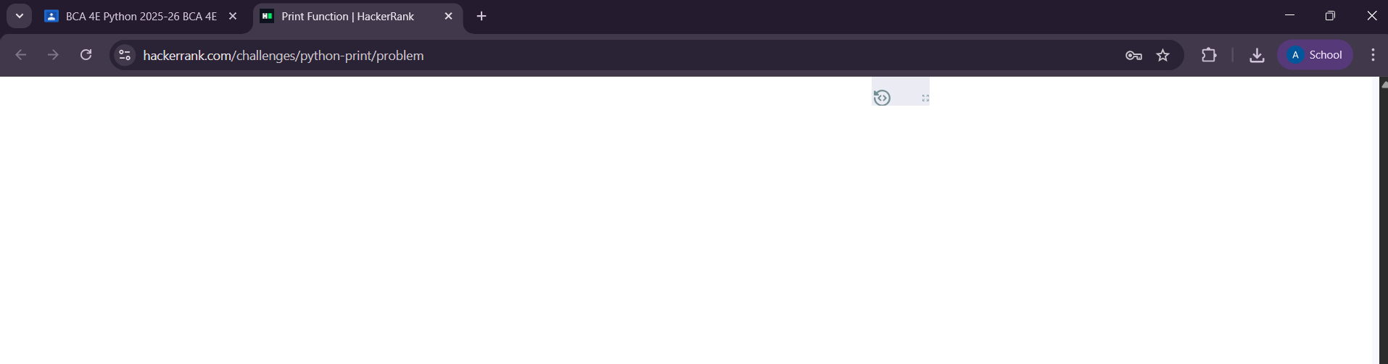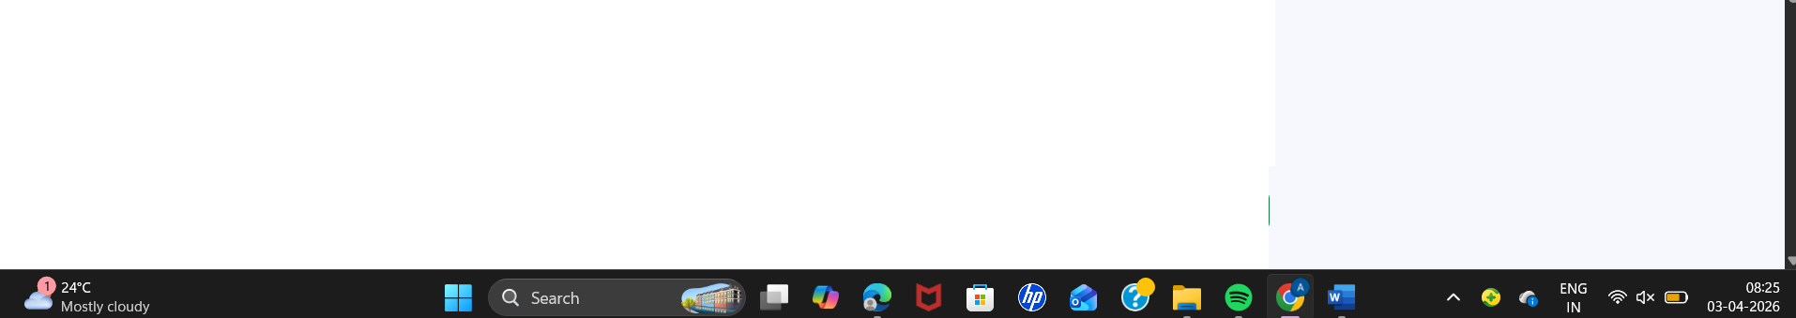Change Theme Language Pypy 3 V •

1
2 n = int(input())
'2
vfor i in range(l, n + 1): print(i, end="")
6

8

Line: 8 Col: 5

( .1 UploadCodeasFile ) Test against custom input ( RunCode ) SubmitCode

Congratulations!
You have passed the sample test cases. Click the submit button to run your code against all the test cases.

0 Sample Test case 0

Input (stdin)

1 3

Download

Your Output (stdout)

1 123

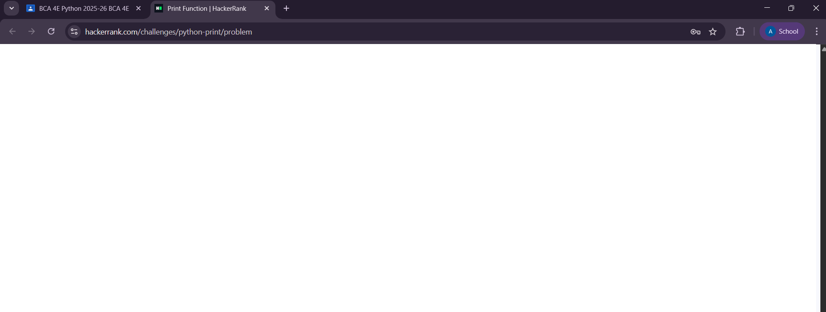Expected Output

1 123
Download

